

<Client Logo>

**Development Specifications Document**

UI Bank

**Version: approval for development**

**Document History**

|  |  |  |  |  |
| --- | --- | --- | --- | --- |
| Date | Version | Name | Organization (Dept.) | Comments |
| 04-03-2024 | Ver. 1 | Eduard Haponov and Paula Ordonez | SOA | First Draft |

**Document Approval Flow**

|  |  |  |  |  |  |
| --- | --- | --- | --- | --- | --- |
| Version | Flow | Role | Name | Organization (Dept.) | Date |
| Ver. 1 | Prepared by | Developers | Eduard Haponov and Paula Ordonez | SOA | 04-03-2024 |
| Ver. 1 | Reviewed by | Team Lead | Waseem Butt | SOA |  |

**Table of Contents**

1. Introduction 4

1.1 Purpose of the document 4

2. Automated Master Project details 4

3. Runtime Guide 5

3.1 Runtime diagram [Architectural structure of the Master Project] 5

3.2 List of packages 5

3.3 Master Project Runtime details 5

4. Project details 7

1.1 Project Name: {Fill in Project name here} 8

1.1.1 Workflow(s) specific to {Project name} 8

5. Other Details 8

2.1 Future improvements: 8

2.2 Debugging tips: 8

2.3 Other Remarks: 8

6. Glossary 8

# Introduction

## Purpose of the document

The process development document outlines the sequence of steps for approving loans manually by clients, involving copying client data and verifying it on the website. Once automated, it involves automatic saving of an Excel file with a client sheet and their personal data, automatic filling of corresponding inputs on the website, saving the results back to the same Excel file, and sending it out.

The document describes the sequence of steps performed as part of the business process, the conditions, and rules of the process prior to automation and how they are envisioned to work after automating it, partly or entirely. This specifications document serves as a base for developers, providing them the details required for applying robotic automation to the selected business process.

# Automated Master Project details

|  |  |  |
| --- | --- | --- |
| # | Item | Details  (Fill in with free text. If not applicable, mark the field as “n/a. No empty fields.) |
| 1 | Master project name and version | UI Bank |
| 2 | Robot type  (specify if the process was automated for FOR or BOR or mix) | Unattended – No human interaction |
| 3 | Is Work Queue used? (Yes/ No) | Yes |
| 4 | Scalable? (Yes/ No)  (can the process be run by multiple robots in parallel) | Yes, Loader Worker |

# Runtime Guide

## Runtime diagram [Architectural structure of the Master Project]

Display the interaction between components (package / robots, Orchestrator queues, and running

order).

Add diagram below:

Loader Process:

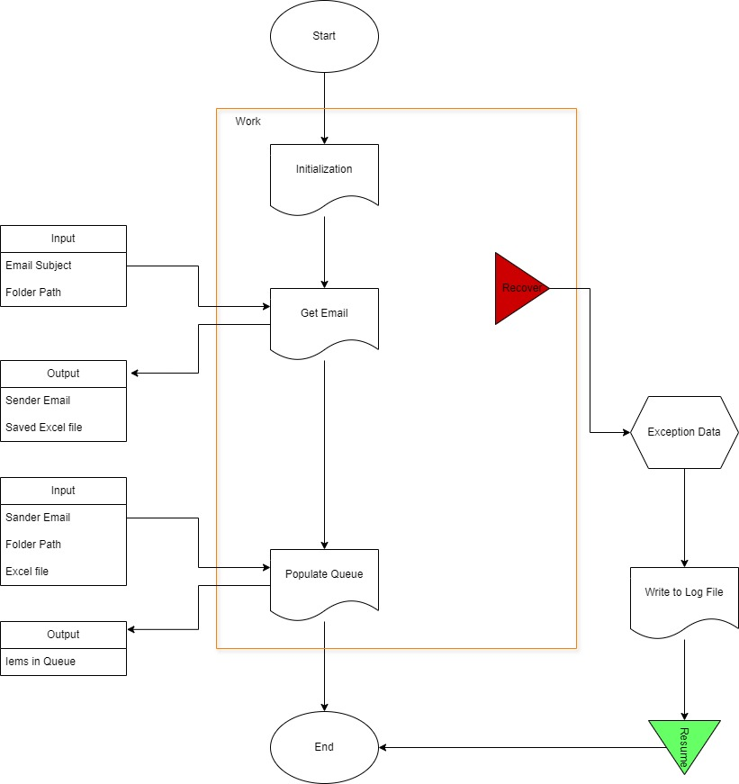

Worker Process:

[Worker Process Diagram](https://ibb.co/XY4MTxQ)

## List of objects

Include the list of objects and the high level description for each of them, to explain each one`s purpose :

|  |  |  |
| --- | --- | --- |
| # | Object name | High Level description |
| 1 | Ui Bank – Basic Actions | The basic actions that this object will have include launching the web, navigating to the "Apply for a Loan" (where it will select "products", “Loans”), logout, and terminating, the latter action being to close the browser. |
| 2 | Ui Bank - Login | This object will only have the action of logging in, to access the website using the user's credentials. |
| 3 | Ui Bank – Create - Loan | This object will work with the loan application interfaces for customers. |

*Add more rows to the table to include all the project names and version. No fields should be left empty. Use “n/a” for the items that don`t apply to your project.

## Master Project Runtime details

Details of the automated process:

|  |  |  |
| --- | --- | --- |
| # | Item | Details  (Fill in with free text. If the section does not apply to your automation, mark the field as “n/a”. No empty fields. ) |
| **1** | **Production environment details** | Running on client computer |
| **2** | **Prerequisites to run** | BluePrism, MS Excel, MS Outlook, Chrome. |
| **3** | **Input Data** | Ui Bank URL, Excel file, Path for saving Excel file, Credentials for Ui Bank. |
| **4** | **Expected Output (output data)** | Excel file, ErrorMessage.txt |
| **5** | **How to start the automated process?** | Start the loader process. After its completion, start the worker process |
| **6** | **Resuming the process from a particular step** | Loader and Worker processes (Initialization Outlook) Worker process (Launch Browser, Navigate, Type Client info, Get results, Send Email) |
| **7** | **Reporting**  (queues reporting, Kibana or another platform) | Session Log |
| **8** | **Manual Error Handling**  (roll back or manually complete failed transactions). Procedures to reset the item. Ex “set status as investigating” | ErrorMessage.txt |
| **7 a. How to resume the process in case of error** | We use a retry mechanism with a maximum of 3 attempts. This retry approach is a common strategy to address temporary issues and continue the process execution successfully. |
| **7 b. How to manually fix transactions with error** | We include actions such as reviewing error logs in "ErrorMessage.txt" to identify root causes of errors. |
| **9** | **Use Queue** | Using a queue to store input data from each row from each excel file |
| **Password policies**  (specific compliance requests?) | Any password change will require the client to provide the correct credentials as a security measure and identity verification. |
| **Stored Credentials:**  (Never hardcode credentials in the workflow) | Saving in BluePrism (system, security, credentials) |
| **List of Asset Names:**  (Follow naming convention ProcessName_AssetName) | TEAM RED (Eduard, Paula) _UI Bank – Loader Process TEAM RED (Eduard, Paula) _UI Bank – Worker Process |
| **List of Queues Names**  (Follow naming convention ProcessName_QueueName) | TEAM RED(Eduard, Paula)_UI Bank - Loader Process |
| **Schedule details:** | N/A |
| **10** | **Multiple resolutions supported**  (in case of image automation/ Citrix) | N/A |
| **Recommended resolution** | N/A |

# Project details

In this section describe all the projects that compose the automated process.

For each project, describe the workflow(s) in the logical order that they are called in.

If the workflow is a flowchart, also include the exported image from Studio.

**If the automated process is composed of multiple projects, copy paste and fill in the table below for each project with its specific details *(Sections 4.1 ; Section 4.2 etc)***

## Project Name: UI Bank

*Add to the title of this section the actual project name of the automated process.*

|  |  |  |
| --- | --- | --- |
| # | Item name | Details  (Fill in with free text. If not applicable, mark the field as “n/a. No empty fields.) |
| **1** | **Environment used for development**  (name, location, configuration details etc) | BluePrism – Version 7.2.1 |
| **2** | **Environment prerequisites**  (OS details, libraries, required apps) | Windows 10/11, BluePrism(VBO - Excel, Outlook, Collection Manipulation, File Management, General, Credential, String, etc), MS Outlook, MS Excel, Chrome. |
| **3** | **Logging level** | Trace |
| **4** | **Details about automation** (if the apps were automated using UI Automation, Image & Text) | Working with the browser was automated using Application Modeller (Browser spy mode). Work with Outlook, Excel, credentials, and collections was automated with the help of the appropriate VBOs |
| **5** | **In case of FOR, can the user operate the computer while the robot is running?** | No |
| **6** | **Repository for project**  (where the developed project is stored) | One Drive, Github |
| **7** | **List of Objects Used in Workflow** | TEAM_RED_UiBank - Basic Actions – Launch Borwser  TEAM_RED_UiBank - Log In – Log In TEAM_RED_UiBank - Basic Actions – Tab menu – 01. Navigate  TEAM_RED_UiBank - Create Loan – 02. Create Loan TEAM_RED_UiBank - Create Loan – Extrac Results – 03. Get Results |
| **8** | **Custom logs defined in the workflows**  **(**where Throw Activity was used or custom log message was defined**)** | 1. Launching a specific URL within a workflow: https://uibank.uipath.com/login  2. Logging in to access the website using client credentials.  3. The work queue contains each item, providing information that serves as inputs to create the loan.  4. Instances where the Throw activity was used to capture specific errors or exceptions.  5. Extracting information into a global collection to write it to an Excel file.  6. Sending an email to the sender's email address. |
| **9** | **Frequent errors found in the development phase** | Description of Errors: Errors of the Excel format type were encountered, which failed due to certain elements such as "?", "£", etc.    Steps Taken for Resolution: Retry mechanism was implemented to ensure the origin of the issue was from the "Create Loan" object. Simply put, in the Loader process, the code was modified to replace these elements with spaces.    Impact Analysis: The errors resulted in disruptions in the process and delays in data processing.    Team Collaboration: Collaboration with development team members was undertaken to resolve complex errors and share best practices for error handling and debugging. |
| **10** | **Workarounds used in the automation phase** | Retry Mechanism: A retry mechanism was employed for specific activities prone to intermittent failures due to external dependencies or network issues.  Data Validation: Data validation processes were established, such as validating Excel sheets and rows before adding them to our queue.  Error Logging and Handling: Robust error logging and handling mechanisms were implemented to capture detailed error messages, facilitating quick identification and resolution of issues during execution. |
| **11** | **Configuration method**  (assets, excel file, Json file) | Configuration via Environment Variables. |
| **12** | **Configuration details**  (path for input files, configuration Orchestrator assets used) | Configuration via Environment Variables: Configuration data such as the URL, file path, file error path, retry limit, subject (email where input files are sent), default loan term, and Excel archive file path were set as Environment Variables. |
| **13** | **Workflow File Export List**  (Use this [TOOL](https://drive.google.com/open?id=0B_Ti7JQEeRYvS3ktRHJiUzhJa0U)) | Main Process: Description: Worker process the overall flow of the automation process. Initialization: This page is responsible for checking if Outlook and Excel are open.  Launch Browser: It is responsible for launching the web page according to the specified URL.  Log In: It handles fetching the client's credentials.    Web Workflow Pages:  01. Navigate: This page navigates on the web and selects "Create Loans."  02. Create Loan: On this page, it inputs the data added in the queue and creates a loan.  03. Get Result: It extracts the results and collects them into a collection called "Result Collections."    Excel Save and Write Pages:  04. Write to Excel: This page writes the results from the Main collection "Completed Result Collection" to an Excel file.  Send Email: Here, the Excel file containing all the collected information is sent to the sender email. |

### Workflow(s) specific to UI BANK

*Add to the title of this section the actual project name to which the workflows are specific to. The name should normally coincide with the Project name mentioned at Section 4.1*

Define below all the workflow files used in the project, with the Input and Output data.

|  |  |  |  |  |
| --- | --- | --- | --- | --- |
| # | Workflow file name | Description | Input | Output |
| 1 | TEAMRED _UI Bank - Loader Process | This workflow initiates the automation process and is responsible for loading data from input files into the queue. | Input files from Outlook | Data loaded into the queue |
| 2 | TEAMRED _UI Bank - Worker Process | This workflow processes the data from the queue and performs actions such as updating loans on the web application based on the information provided in the Excel file. After this, it updates the information in the same Excel file and sends the Excel file via Outlook (with the recipient being the same as the one who sent the input files). | Data from the queue | Output file (update information from the web) |

*\*Add more rows to the table to include all the workflow file names. No fields should be left empty. Use “n/a” for the items that don`t apply to your project.*

*If the workflow is a flowchart, also include below the exported image from Studio.

**Start the list with the one that will run by default when the package is executed.

# Other Details

1. User Credentials
2. Web application URL: [UiBank (uipath.com)](https://uibank.uipath.com/login)

# Glossary

Master project - the overall output of the development, containing one or multiple projects that together cover the scope of the robotic process automation.

Project - an UiPath Studio project containing one or multiple workflow files. A project can be converted to a package and run independently, covering a particular scope within the master project. The project is used when defining the development and support phase of the automation.

Package - the output of compiling a project. A package can be deployed on the robot machine and be executed by the robot service. Only one package can be executed at a given time by a robot. The package is used when defining the running phase of the automation

Workflow - a component of the package, the workflow encapsulates a part of the project logic. The workflow can be of type: sequence, flowchart or state machine. a workflow is saved as an .xaml file inside the project folder. A workflow file can be invoked from another workflow and by default there is an initial workflow file that will run when executing the package.

Activity - an action that the robot executes.

Sequence - a workflow where activities are executed one after another, in a sequential order

Flowchart - a workflow where activities are connected by arrows and the logic of the workflow can be easily followed in a visual manner. The flowchart can also be exported as an image from UiPath studio

State machine - a more advanced way of organizing a workflow, similar to a flowchart.

BOR - Back office robot

FOR – Front office robot

Orchestrator – Enterprise architecture server platform supporting: release management, centralized logging, reporting, auditing and monitoring tools, remote control, centralized scheduling, queue/robot workload management, assets management.